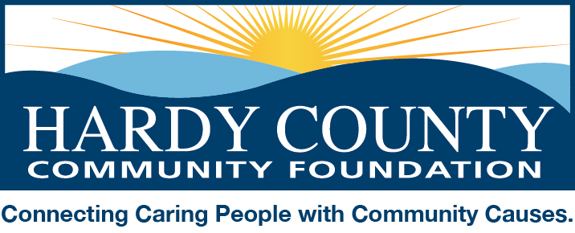

June 6, 2017

Dear Friends:

The Hardy County Community Foundation is gearing up for its fourth annual Volunteer Hardy event, which seeks to call attention to the many volunteer and nonprofit organizations serving Hardy County and the critical role they play in making their communities thrive. The Community Foundation views this initiative as an opportunity to promote volunteerism and encourage support for our local community service sector. This year’s initiative will take place during the months of August and September.

Here’s how it works:

Nonprofit organizations are invited to coordinate fundraising activities some time during the months of August or September (excluding Heritage Weekend) to support their own missions as well as help build the Community Foundation’s Community Impact Fund (our unrestricted endowment which is used to support a variety of local nonprofits and charitable programs). The Community Foundation will help promote these events and issue periodic calls-to-action encouraging people to learn more about the participating organizations and get involved.

In November we will highlight the efforts of all participating organizations at our Spirit of Hardy County celebration. The Community Foundation will invite four organizations to select one of their members who exemplifies the volunteer spirit for their organization to be recognized at the dinner.

Attached is a summary of what the Community Foundation will do and what we are asking participating non-profits to do, including deadlines for responding. We hope you will consider joining us in this annual celebration of volunteerism and the non-profit sector in Hardy County.

Please contact me by email (apancake@ewvcf.org) or phone (304-538-3431) for more information or to notify us of your intent to participate. And please feel free to pass this information along to other volunteer-based organizations.

I look forward to hearing from you soon!

Sincerely,

Amy Pancake

Hardy County Community Foundation - 2017 Volunteer Hardy Details

The Community Foundation will:

- Invite local nonprofits to participate in the initiative
- Promote each organization’s fundraising activity as part of the Volunteer Hardy event. Promotion includes posts on Facebook, poster-sized flyers displayed in places of business throughout the county, announcements on WELD, and paid advertising through the Moorefield Examiner (inclusion in paid advertising and posters is contingent on receiving event details by July 22nd for August events and August 18th for September events)
- Host the Spirit of Giving dinner to celebrate volunteerism as the Spirit of Hardy County. During the dinner we will highlight the efforts of all participating organizations, and recognize four individuals selected by each of the four organizations whose efforts truly embody the volunteer spirit.
- Make an effort to have a representative from the foundation at each Volunteer Hardy event

We are asking the participating nonprofit to:

- Notify the HCCF of its intent to participate in the Volunteer Hardy event by July 14th.
- LIKE our Facebook page (https://www.facebook.com/HardyCountyCommunityFoundation) and visit it frequently to help share information about the event.
- Coordinate a fundraising activity to take place during the month of August or September and provide details of the event to the HCCF by July 21st (August events) or August 18th (September events).
- Keep 80% of funds raised to use for its own charitable purposes and contribute 20% of the net proceeds to the Community Foundation to help build the Community Impact fund.
- Plan to attend our Spirit of Hardy County celebration dinner in November.

Four participating organizations will be invited to select a volunteer to be honored at the Spirit of Hardy celebration, and will be asked to introduce him/her or to provide comments about the individual to be read by a HCCF board member.

Please email intent to participate and event details (including information below) to apancake@ewvcf.org.
- Name of organization
- Name/phone/email of contact person (for correspondence with HCCF)
- Website or where to find more information (to include in promotional material)
- Details about your event:
  - Brief description of fund raising activity
  - Date, time, and location (please do not schedule Volunteer Hardy fundraising events during Heritage Weekend – September 22, 23, and 24).
- Optional – Details about your organization (meetings days/times; types of activities; how to become a member) for us to post on Facebook periodically

Please note: In order to have your activity included in paid advertising, we must have details no later than July 21st for events taking place in August and August 18th for events taking place in September.

